**ARKANSAS AMERICAN RESCUE PLAN ACT STEERING COMMITTEE**

**ARPA Funding Request from the Department of Human Services**

**Supporting Evidence-Based Behavioral Health Models in Arkansas**

**August 26, 2022**

While Arkansas has made significant improvements to the public mental health system, gaps remain in access to care for some populations due to the complexity of their behavioral health needs. The lack of community-based, evidence-based practice has led to increased recidivism in the State’s forensic system, resulting in individuals remaining in jail awaiting admission to an appropriate treatment setting. In addition, children and youth are cycling through psychiatric acute and residential settings with little time to establish sufficient supports in the community. This is causing additional strain on the Child Welfare and Juvenile Justice systems.

Therefore, this proposal seeks to use a portion of the American Rescue Plan Act of 2021’s (ARPA) State Fiscal Recovery Funds (SFRF) Arkansas Allotment to support the training and certification of teams employed by Behavioral Health Agencies (BHAs) in evidence-based models. Specifically, 1) the Assertive Community Treatment (ACT) Model for adults with the highest level of mental health needs; and 2) Intensive In-Home Support Model (IHHS) to serve a similar population of children and youth in Arkansas, who are involved with or at risk of involvement with the Child Welfare or Juvenile Justice System. Simultaneously, DHS is working with a behavioral health task force comprised of legislators, healthcare policy leaders, behavioral health providers, PASSEs, and other stakeholders to identify and fill gaps in services, develop an appropriate rate structure for home and community-based models, and establish expectations regarding the population these teams will serve and services these teams will provide.

To provide appropriate and adequate training, the Department of Human Services (DHS) will contract with procured vendors to allow Qualified BHAs to apply for and complete training in the ACT and IHHS models.

This training will allow Qualified BHAs to expand their treatment capabilities and serve more Arkansans who need 24 hour supports from a team of Behavioral Health Clinicians and Support Staff. We expect this Staff to provide the necessary intensive, team-based treatment to maintain individuals in home and community-based settings.

Therefore, DHS requests $5,000,000 in ARPA funding to provide training and certification in ACT and IHHS to Qualified BHAs, in order to support necessary evidence-based expansion of behavioral health services.

**Qualified BHAs:** To receive funding under this proposal, the entity must be an Arkansas Medicaid enrolled Behavioral Health Agency or Community Support Services Provider. Participating providers may be privately owned, county or municipal-owned, or state-owned.

**Disbursement of Funds:**

Eligible BHA providers must submit a letter of intent for approved training and related expenses through the Division of Aging, Adult and Behavioral Health Services by October 1, 2022. DAABHS will begin accepting application on October 1, 2022, and ending December 1, 2024, or until all funds are expended.

The requested funding will be used for training, monitoring, supervision, and certification for the Assertive Community Treatment Model to serve those adults with the highest level of mental health needs within the PASSE and to those with Medicare who qualify for Medicaid through the Spenddown category; as well as Intensive In-Home Services for children and youth who qualify for Medicaid and receive services within the PASSE.

* To receive funding the Qualified BHA must submit an application that identifies the number of teams to be trained, who will be trained on each team, and what role they will serve.
* Team selection would be based on need as identified in PASSE and Medicaid claims data, as well as, by geographic area based on the distribution of the eligible population.

**Allotment Determination**:

1. Assertive Community Treatment:

* Provide funding for training, monitoring, supervision, and provider certification for up to 100 teams.
* Estimated training cost is $20,000 per team. (See Cost Information below)
* **Total funding requested: $2,000,000**

1. Intensive In-Home Services (IHHS)

* Provide funding for training, monitoring, supervision, and provider certification for up to 100 teams.
* Estimated training cost is $30,000 per team. (See Cost Information below)
* **Total funding requested: $3,000,000**

**Restrictions on Funds:** Recipients of funds will be required to attest that these funds are necessary to cover expenses incurred during the program period to address extraordinary costs related the to the PHE, including but not limited to closing critical gaps in infrastructure, capacity, and sustainability; and that none of these funds will be used to:

* Duplicate or supplant funding from any other federal or state program. Payments or other reimbursement for direct patient care is not included as funding from a federal or state program.

To the extent that expenses are subsequently reimbursed under another federal or state program, funds disbursed from the state’s portion of the American Rescue Plan approved by the American Rescue Plan Act Steering Committee and authorized by the Arkansas Legislative Council will be reconciled and recovered.

**Application and Expense Review:**

Qualified BHAs will be required to submit an application attesting to the requirements and limitations outlined above (form to be created by DHS) signed by the Qualified BHA’s CEO or the equivalent.

Funds must be expended no later than December 1, 2024. Documentation of expenditure of funds will be subject to audit and review by DHS and must be submitted by July 31, 2025. Any funding that is not supported by expense documentation will be recovered.

**Cost Information:**

Cost Determination for ACT:

[1]

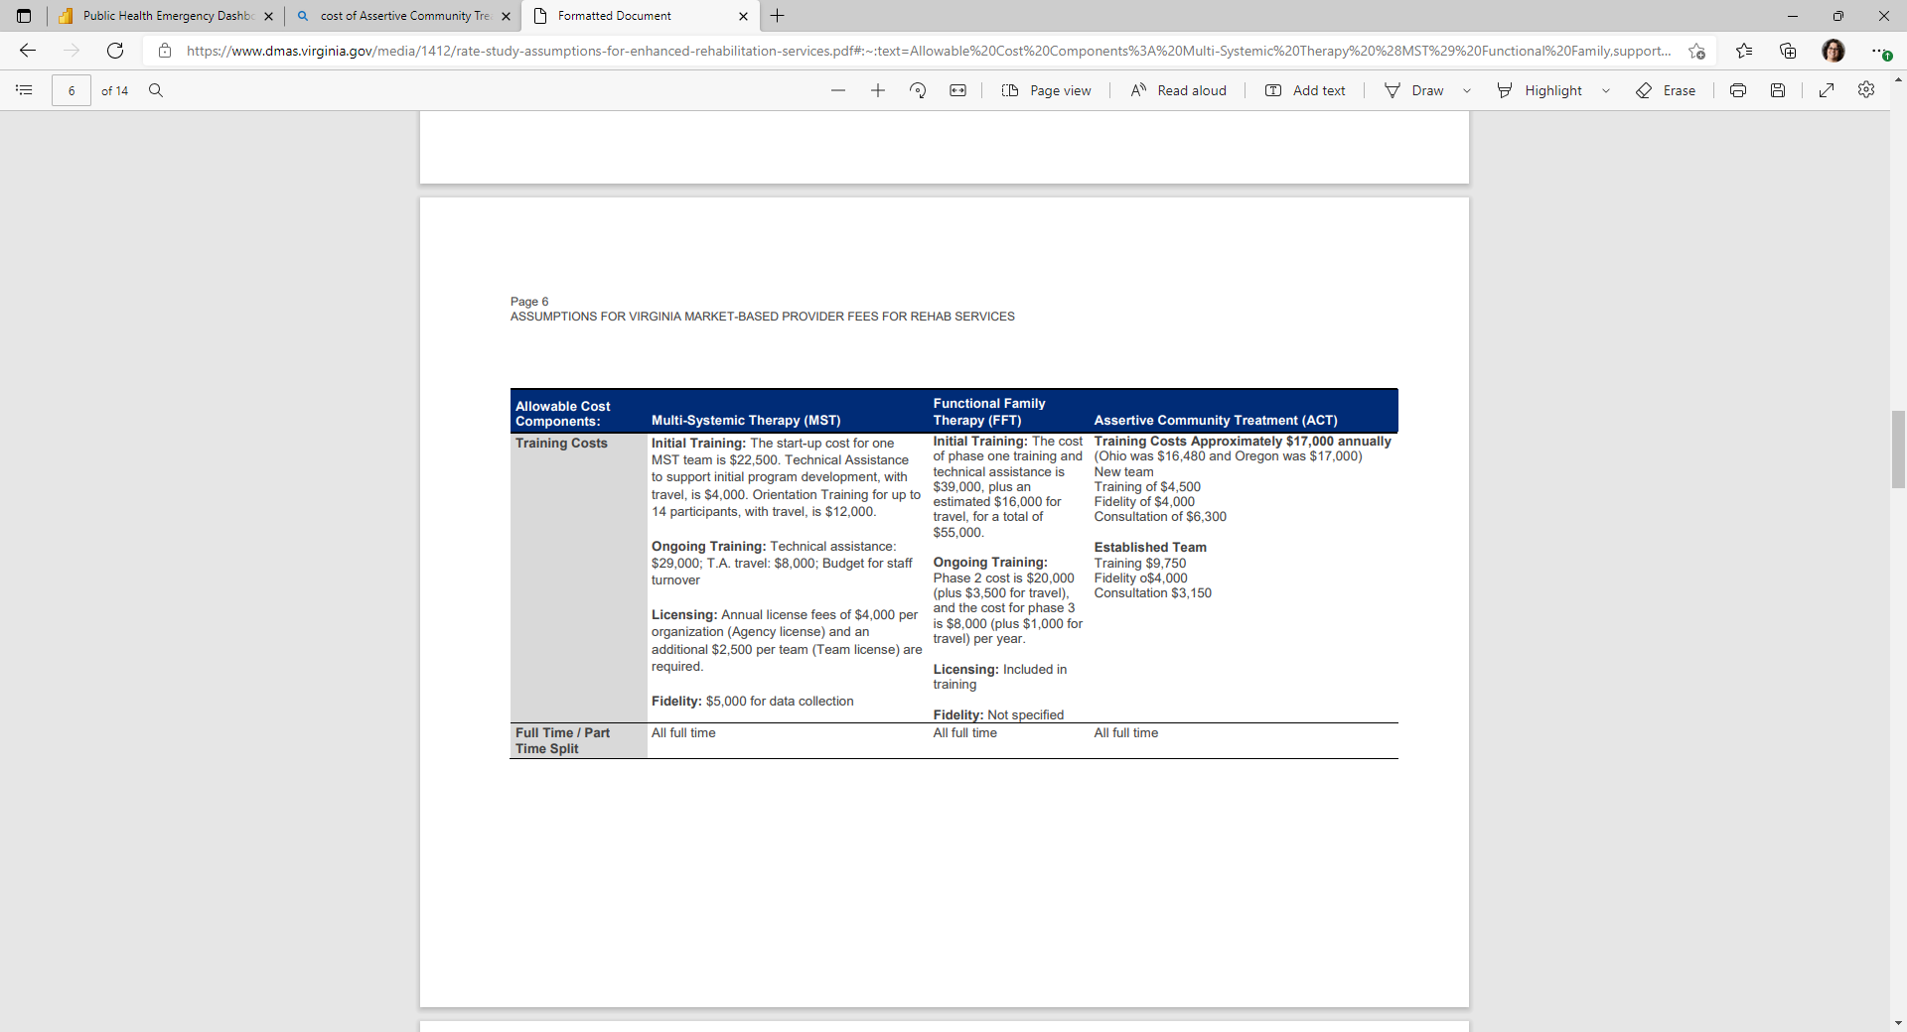

[2]

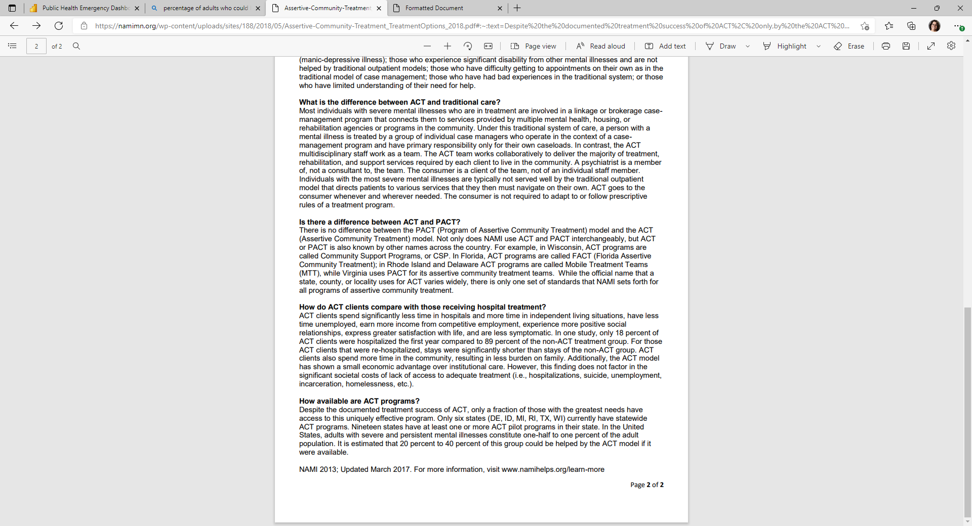

Cost Determination for IHHS Model: [3]



1. [Formatted Document (virginia.gov)](https://www.dmas.virginia.gov/media/1412/rate-study-assumptions-for-enhanced-rehabilitation-services.pdf#:~:text=Allowable%20Cost%20Components%3A%20Multi-Systemic%20Therapy%20%28MST%29%20Functional%20Family,support%20initial%20program%20development%2C%20with%20travel%2C%20is%20%244%2C000.)
2. [Assertive-Community-Treatment_TreatmentOptions_2018.pdf (namimn.org)](https://namimn.org/wp-content/uploads/sites/188/2018/05/Assertive-Community-Treatment_TreatmentOptions_2018.pdf#:~:text=Despite%20the%20documented%20treatment%20success%20of%20ACT%2C%20only,by%20the%20ACT%20model%20if%20it%20were%20available.)
3. [https://www.blueprintsprograms.org/programs/32999999/multisystemic-therapy-mst/print/](https://gcc02.safelinks.protection.outlook.com/?url=https%3A%2F%2Fwww.blueprintsprograms.org%2Fprograms%2F32999999%2Fmultisystemic-therapy-mst%2Fprint%2F&data=05%7C01%7CAnthony.Jackson.DHS%40dhs.arkansas.gov%7Cc43f4635631d40031cf108da876f88b5%7C5ec1d8f0cb624000b3278e63b0547048%7C1%7C0%7C637971210361759682%7CUnknown%7CTWFpbGZsb3d8eyJWIjoiMC4wLjAwMDAiLCJQIjoiV2luMzIiLCJBTiI6Ik1haWwiLCJXVCI6Mn0%3D%7C3000%7C%7C%7C&sdata=L%2B%2FvLsLs2bJcAvpm9PQrAVW2z%2F3sf1zPCv67whNok68%3D&reserved=0)

  