The State of Arkansas, Department of Finance and Administration – Intergovernmental Services (IGS) under the U.S. department of Justice’s Oﬃce of Justice Programs’ (OJP) Bureau of Justice Assistance (BJA) Justice Assistance program (JAG) announces a one-time opportunity for additional funding to Local Law Enforcement Block Grant for a grant cycle of April 29th, 2024 - September 30, 2024. These subawards will receive $7,400.00 to be used for equipment listed below:
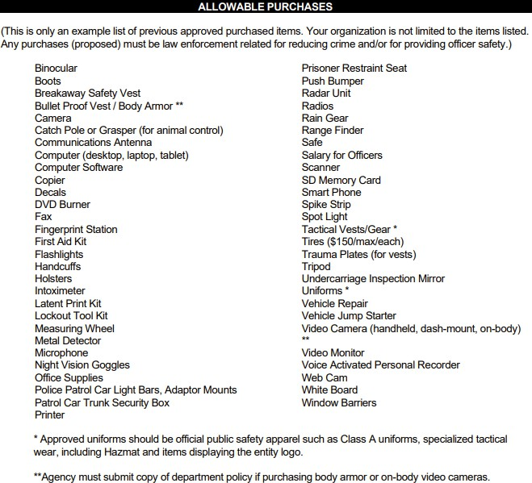

The forms can be found on https://www.dfa.arkansas.gov/intergovernmental-services/. The forms are to be completed by your agency and returned by 4:30 p.m., Friday, April 19, 2024. Failure to complete these forms and returned by this date, the application will not be reviewed. If you have any questions, please feel free to call Alicia Christopher at 501-324-9494 or email at Alicia.christopher@dfa.arkansas.gov.

